First Grade Homework! Week of February 11, 2019
 | Monday | Tuesday | Wednesday | Thursday | Friday
Fundations | Please practice your Fundations words by completing three different activities in a row by Friday in your Fundations homework book. The menu can be found on the back of the homework sheet. Three in a row can be vertical, horizontal or diagonal.
Math | Complete your exit ticket that is attached. | Complete your exit ticket that is attached. | Complete your exit ticket that is attached. | Complete your exit ticket that is attached.
Reading | Read for 15 minutes.  What did you read?  __________________ | Read for 15 minutes.  What did you read?  __________________ | Read for 15 minutes.  What did you read?  __________________ | Read for 15 minutes.  What did you read?  __________________
How was my day?  Parent signature required  on line provided | Pink Purple  Blue Green  Yellow Orange  Red  __________________ | Pink Purple  Blue Green  Yellow Orange  Red  __________________ | Pink Purple  Blue Green  Yellow Orange  Red  __________________ | Pink Purple  Blue Green  Yellow Orange  Red  __________________ | Pink Purple  Blue Green  Yellow Orange  Red  __________________

*Field trip tomorrow (weather pending) 2/12 to Art Museum

*1pm early dismissal for students Friday, 2/15
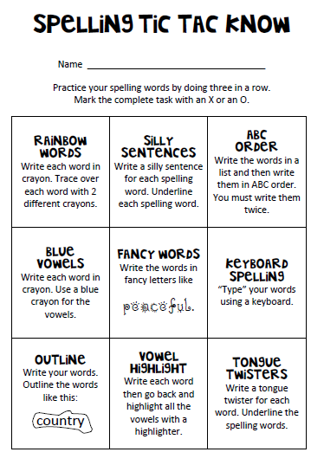
Fundations Words
1. chills
2. maps
3. tops
4. necks
5. bells
6. rugs
7. packs
8. jugs
9. bugs
10. ships

