First Grade Homework! Week of April 15, 2019
 | Monday | Tuesday | Wednesday | Thursday | Friday
Fundations | Please practice your Fundations words by completing three different activities in a row by Friday in your Fundations homework book. The menu can be found on the back of the homework sheet. Three in a row can be vertical, horizontal or diagonal.
Math | Complete your exit ticket that is attached. | Complete your exit ticket that is attached. | Complete your exit ticket that is attached. | Complete your exit ticket that is attached.
Reading | Read for 15 minutes.  What did you read?  __________________ | Read for 15 minutes.  What did you read?  __________________ | Read for 15 minutes.  What did you read?  __________________ | Read for 15 minutes.  What did you read?  __________________
How was my day?  Parent signature required  on line provided | Pink Purple  Blue Green  Yellow Orange  Red  __________________ | Pink Purple  Blue Green  Yellow Orange  Red  __________________ | Pink Purple  Blue Green  Yellow Orange  Red  __________________ | Pink Purple  Blue Green  Yellow Orange  Red  __________________ | Pink Purple  Blue Green  Yellow Orange  Red  __________________
Name: ___________________

*First grade will be going to Paws Discovery Farm Tuesday and Ms. Conaboy’s class will be going painting on Wednesday and Ms. McGee’s class will be going on Thursday. (Ms. Newell’s class will be split both days)

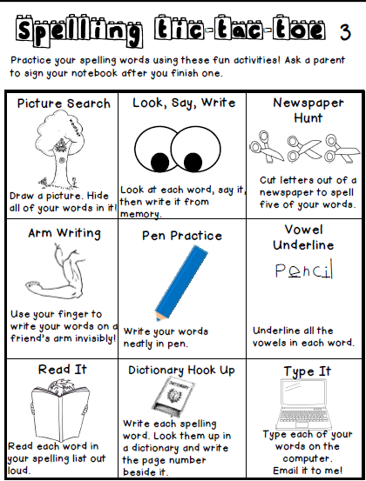
Fundations Words
- wax
- there
- where
- have
- come
- some
- two
- rash
- wish
- sits

