First Grade Homework! Week of December 17, 2018
 | Monday | Tuesday | Wednesday | Thursday | Friday
Fundations | Please practice your Fundations words by completing three different activities in a row by Friday in your Fundations homework book. The menu can be found on the back of the homework sheet. Three in a row can be vertical, horizontal or diagonal.
Math | Complete your exit ticket that is attached. | Complete your exit ticket that is attached. | Complete your exit ticket that is attached. | Complete your exit ticket that is attached.
Reading | Read for 15 minutes.  What did you read?  __________________ | Read for 15 minutes.  What did you read?  __________________ | Read for 15 minutes.  What did you read?  __________________ | Read for 15 minutes.  What did you read?  __________________
How was my day?  Parent signature required  on line provided | Pink Purple  Blue Green  Yellow Orange  Red  __________________ | Pink Purple  Blue Green  Yellow Orange  Red  __________________ | Pink Purple  Blue Green  Yellow Orange  Red  __________________ | Pink Purple  Blue Green  Yellow Orange  Red  __________________ | Pink Purple  Blue Green  Yellow Orange  Red  __________________

*Holiday Show is December 21st
**Early dismissal 1 pm December 21st

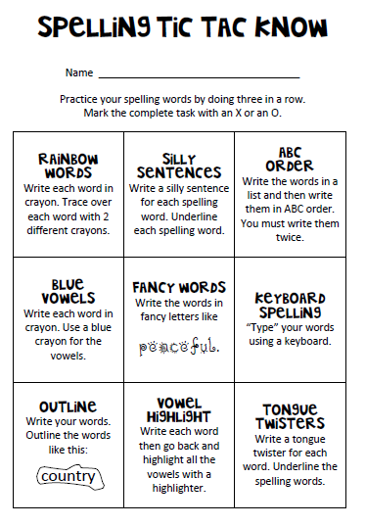
Fundations Words
1. be
2. me
3. luck
4. sock
5. wish
6. math
7. dock
8. such
9. dish
10. bath

