 | Monday | Tuesday | Wednesday | Thursday | Friday
Fundations | Please practice your Fundations words by completing three different activities in a row by Friday in your Fundations homework book. The menu can be found on the back of the homework sheet. Three in a row can be vertical, horizontal or diagonal.
Math | None | Catch up to Module 2 Lesson 28 on Zearn | Module 2, Lesson 29 on Zearn | No homework/Catch up to lesson 29
Reading | Read for 15 minutes.  What did you read?  __________________ | Read for 15 minutes.  What did you read?  __________________ | Read for 15 minutes.  What did you read?  __________________ | Read for 15 minutes.  What did you read?  __________________
How was my day?  Parent signature required  on line provided | Pink Purple  Blue Green  Yellow Orange  Red  __________________ | Pink Purple  Blue Green  Yellow Orange  Red  __________________ | Pink Purple  Blue Green  Yellow Orange  Red  __________________ | Pink Purple  Blue Green  Yellow Orange  Red  __________________ | Pink Purple  Blue Green  Yellow Orange  Red  __________________
Reminders:
**Math Quiz Friday 3/24
**Science Quiz Friday 3/24

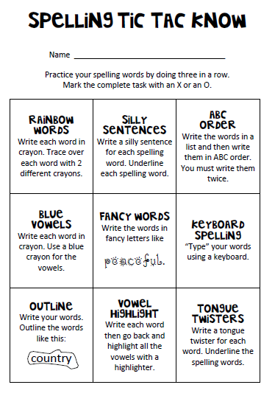
Fundations Words
- sent
- must
- lend
- black
- chest
- raft
- clock
- camp
- frog
- click

