First Grade Homework! Week of May 13, 2019
 | Monday | Tuesday | Wednesday | Thursday | Friday
Fundations | Please practice your Fundations words by completing three different activities in a row by Friday in your Fundations homework book. The menu can be found on the back of the homework sheet. Three in a row can be vertical, horizontal or diagonal.
Math | Complete your exit ticket that is attached. | Complete your exit ticket that is attached. | Complete your exit ticket that is attached. | Complete your exit ticket that is attached.
Reading | Read for 15 minutes.  What did you read?  __________________ | Read for 15 minutes.  What did you read?  __________________ | Read for 15 minutes.  What did you read?  __________________ | Read for 15 minutes.  What did you read?  __________________
How was my day?  Parent signature required  on line provided | Pink Purple  Blue Green  Yellow Orange  Red  __________________ | Pink Purple  Blue Green  Yellow Orange  Red  __________________ | Pink Purple  Blue Green  Yellow Orange  Red  __________________ | Pink Purple  Blue Green  Yellow Orange  Red  __________________ | Pink Purple  Blue Green  Yellow Orange  Red  __________________
Name: ___________________

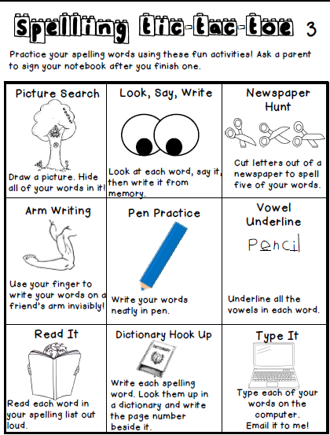

Fundations Words
- stuff
- vest
- press
- pinch
- brags
- her
- plum
- dress
- drum
- should

