 | Monday | Tuesday | Wednesday | Thursday | Friday
Fundations | Please practice your Fundations words by completing three different activities in a row by Friday in your Fudations homework book. The menu can be found on the back of the homework sheet. Three in a row can be vertical, horizontal or diagonal.
Math | Complete your exit ticket that is attached. | Complete your exit ticket that is attached. | Complete your exit ticket that is attached. | Complete your exit ticket that is attached.
Reading | Read for 15 minutes.  What did you read?  __________________ | Read for 15 minutes.  What did you read?  __________________ | Read for 15 minutes.  What did you read?  __________________ | Read for 15 minutes.  What did you read?  __________________
How was my day?  Parent signature required  on line provided | Pink Purple  Blue Green  Yellow Orange  Red  __________________ | Pink Purple  Blue Green  Yellow Orange  Red  __________________ | Pink Purple  Blue Green  Yellow Orange  Red  __________________ | Pink Purple  Blue Green  Yellow Orange  Red  __________________ | Pink Purple  Blue Green  Yellow Orange  Red  __________________

Reminders: Linvilla Orchard Field Trip Monday, 11/5

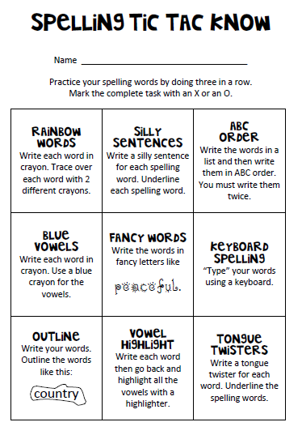
Fundations Words

- Sad
- Mad
- Map
- Rag
- Rat
- Nag
- Nap
- Sip
- Sit
- Rip

