Dear Parents/Guardians,

October is National Pizza Month! In celebration of this month, students will need to complete 1 math and 1 writing activity about pizza. Please carefully review the rubric below and assist your child in completing all parts of this project. Be sure to follow all directions in order to help your child earn the maximum number of points. Students may choose to display their projects in any way! They may return it as a packet, display it on poster board, use a pizza box- be creative! Projects are due by **Wednesday October 30, 2018.**  Please feel free to contact me with any questions or concerns! Thank you!

Sincerely,

Ms Conaboy ☺

**National Pizza Month Project Rubric**

***Math Portion (10 pts.)***

*Students will interview 10 people and collect data on their favorite pizza topping. Students will complete the bar graph (included in this packet) to display their data. Students will answer the attached question using their graph to accurately respond.*

|  |  |
| --- | --- |
| Student surveyed 10 people and graph is accurately complete. | ________/5 |
| Student has answered all graphing questions appropriately. | ________/3 |
| Student can explain the finding of their graph. | ________/2 |
| Total | _______/10 |

***Writing Portion (10 pts.)***

*Students will use the included writing prompt to answer questions about their own pizza shop.*

|  |  |
| --- | --- |
| Student responded to all questions with complete sentences. | ________/2 |
| Sentences begin with a capital letter and end with a period. | ________/2 |
| Student work is free from spelling errors. | ________/2 |
| Student work is creative and demonstrates their best effort. | ________/2 |
| Student writing is neat and legible. | ________/2 |
| Total | _______/10 |

*\*\*1 point will be deducted per day for late project.*

*\*\*Please be sure that your child’s name is visible on the front of their project.*

Name __________________________________ Room Number _______________

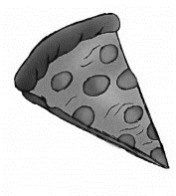

**Pizza Survey**

Number of Votes

|  |  |  |  |
| --- | --- | --- | --- |
|  |  |  |  |
|  |  |  |  |
|  |  |  |  |
|  |  |  |  |
|  |  |  |  |
|  |  |  |  |
|  |  |  |  |
|  |  |  |  |
|  |  |  |  |
|  |  |  |  |
| **Cheese** | **Pepperoni** | **Veggie** | **Other** |

**Favorite Pizza Topping**

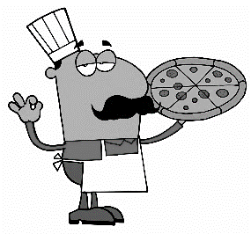Name __________________________________ Room Number _______________

**Pizza Survey Questions**

**Directions: Use your graph to answer the questions below. Please respond with complete sentences.**

1. **What topping did the MOST people like?**

**_______________________________________________________________________________________________________________________________________________________________________________________________________________________________________**

1. **What topping did the FEWEST number of people like?**

**_______________________________________________________________________________________________________________________________________________________________________________________________________________________________________**

1. **What were some toppings that people who choose “other” liked best?**

**_______________________________________________________________________________________________________________________________________________________________________________________________________________________________________**

1. **What is YOUR favorite pizza topping?**

**_______________________________________________________________________________________________________________________________________________________________________________________________________________________________________**

