Name: ______________________________________ First Grade Homework!
Week of December 9-13 2019
 | Monday | Tuesday | Wednesday | Thursday | Friday
Fundations | Please practice your Fundations words by completing three different activities in a row by Friday in your homework notebook. The menu can be found on the back of the homework sheet. Three in a row can be vertical, horizontal or diagonal.
Math | Students can go to Zearn.com and type in their login and password. Class code: CT2P2Q. Monday: Lesson 33. Tuesday: Lesson 34. Wednesday: Lesson 36. Thursday: Lesson 37.
Reading | Read for 15 minutes.  What did you read?  __________________ | Read for 15 minutes.  What did you read?  __________________ | Read for 15 minutes.  What did you read?  __________________ | Read for 15 minutes.  What did you read?  __________________
How was my day?  Parent signature required  on line provided | Pink Purple  Blue Green  Yellow Orange  Red  __________________ | Pink Purple  Blue Green  Yellow Orange  Red  __________________ | Pink Purple  Blue Green  Yellow Orange  Red  __________________ | Pink Purple  Blue Green  Yellow Orange  Red  __________________ | Pink Purple  Blue Green  Yellow Orange  Red  __________________

Fundations Words
1. was
2. one
3. said
4. toss
5. ball
6. lash
7. pack
8. will
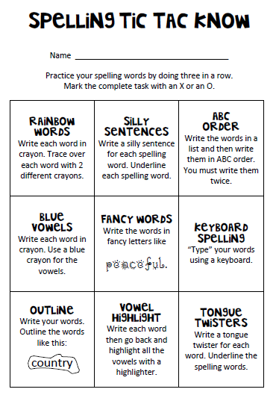
9. mess
10. lock

